**Installing Of Linux And Configuration As Dual Boot With Both Windows And Linux**

**Prerequisites**

Before we begin, we assumes that you already have a properly functioning Windows installation on your system. If the installation has become corrupt or otherwise inaccessible, this isn't going to work.

You also need to make sure that you still need to grab yourself a copy. We also have a hard drive space.dedicated [GUIDE ON CREATING A MANJARO BOOTABLE USB](https://linuxconfig.org/create-manjaro-linux-bootable-usb).

## Resize Windows 10 hard disk partition

If you're planning on installing Manjaro to the same hard drive where Windows 10 is installed, you'll need to make sure Manjaro has its own partition and enough space on said partition. More than likely, your Windows 10 installation is currently taking up the entire hard disk. This is no problem, because Windows gives us an easy way to shrink the partition and make room for Manjaro. Manjaro's [system requirements](https://linuxconfig.org/manjaro-linux-system-requirements) recommend at least 30 GB of

On Windows 10, open up the Disk Management utility by searching for it in the start men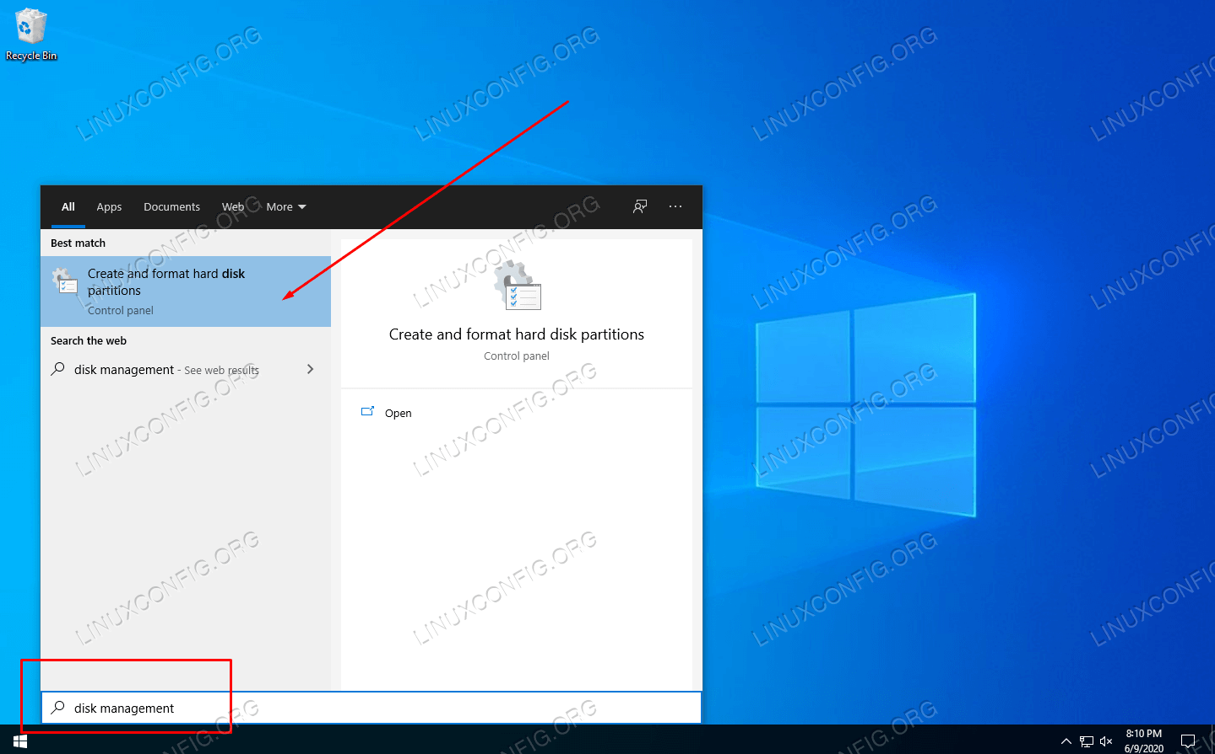

Your Disk Management menu should look similar to the screenshot below. As long as you can spare 30 GB or more from your C: drive, right click on your partition with drive letter C: and click on shrink volume.

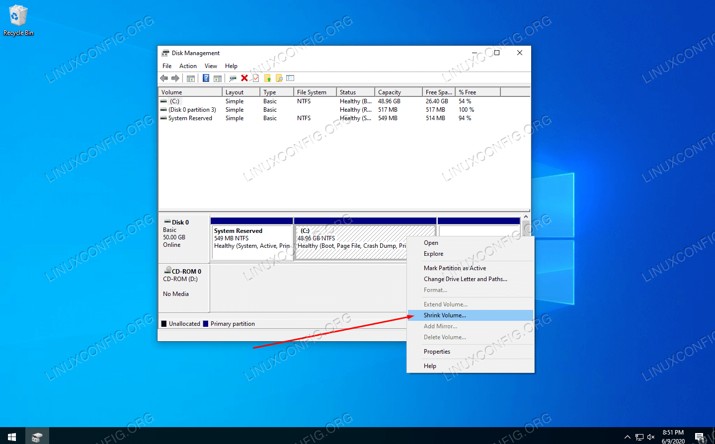

In the box indicated in the screenshot below, enter the size (in MB) that you want your Manjaro partition to be. After you've entered an amount, click shrink to begin resizing your Windows partition.

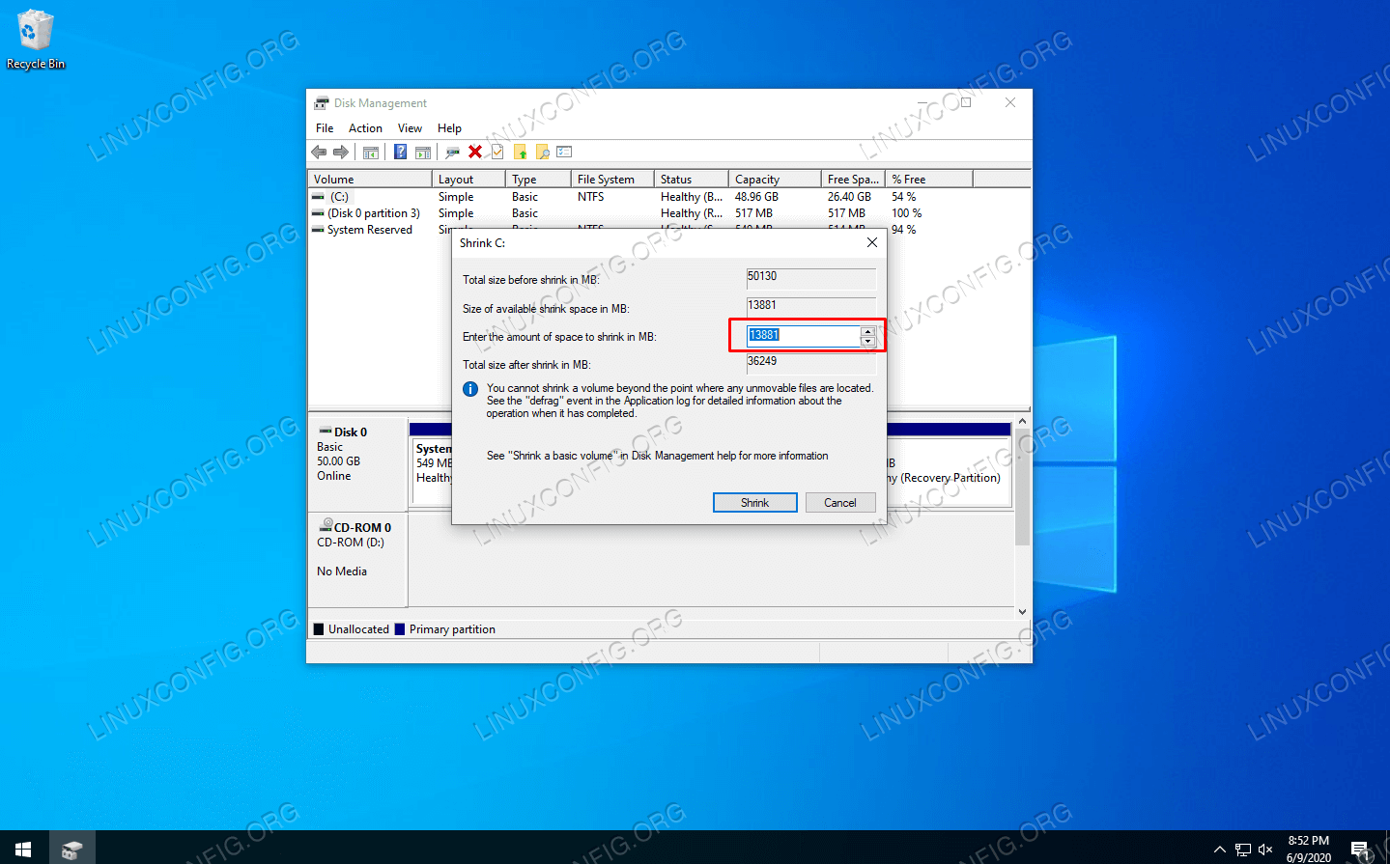

Windows may take a few moments to finish resizing your disk. As you can see in the screenshot below, we're left with a certain amount of "unallocated space." This unallocated space is where Manjaro will be installed. 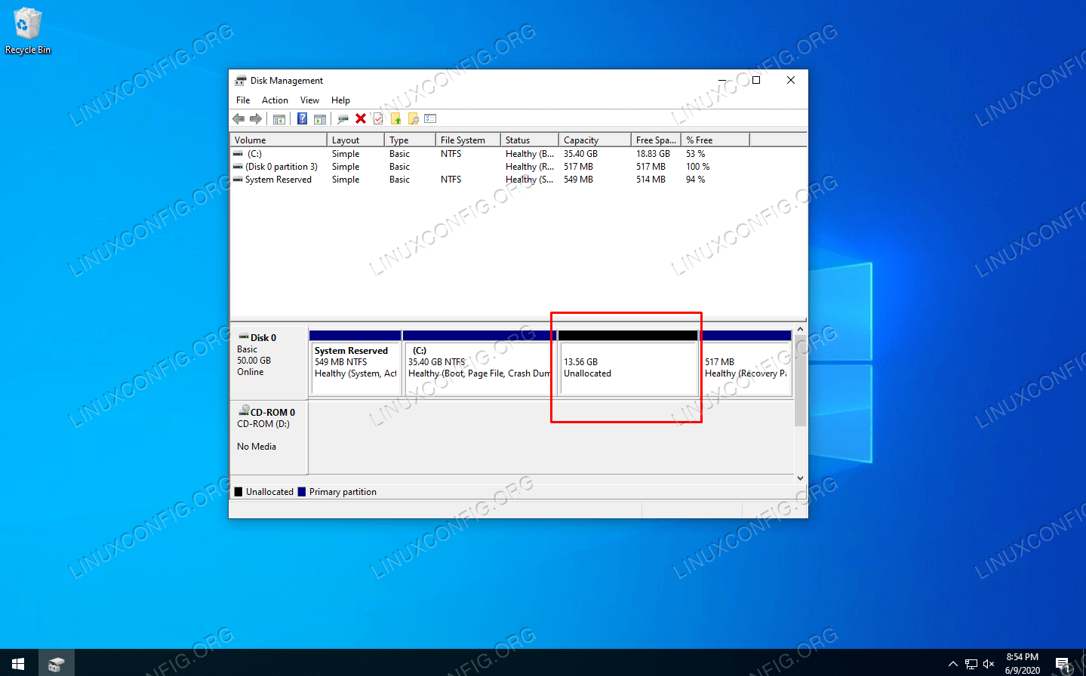

## Install Manjaro Alongside Windows 10

1. Insert your Manjaro installation media into the USB port or disc tray and reboot your system. As it comes back up, load into the installation media. You may need to press F11, F12, or Esc on your keyboard in order to access the boot menu and select your installation media.
2. You'll see the Manjaro welcome screen. Click Enter to load into Manjaro's [live environment](https://linuxconfig.org/live-cd-dvd-linux-download).

[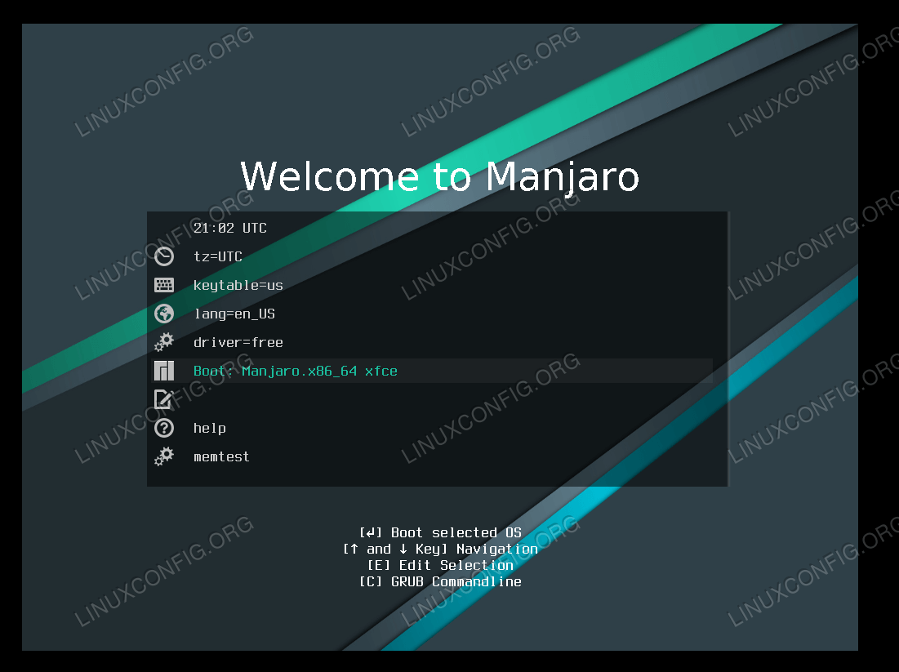](https://linuxconfig.org/images/05-manjaro-linux-windows-10-dual-boot.png)BOOT INTO MANJARO LIV ENVIRONMENT

3.Once your system finishes loading into the Manjaro live environment, click on Launch Installer.  
 [[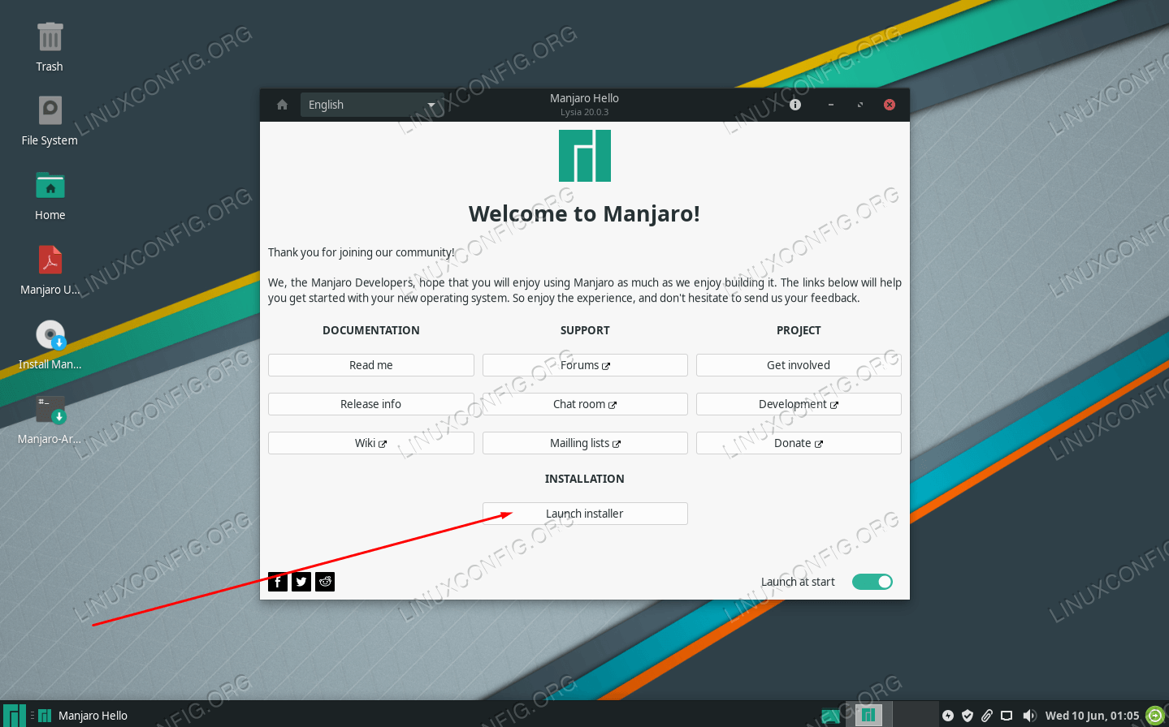](https://linuxconfig.org/images/06-manjaro-linux-windows-10-dual-boot.png)](https://linuxconfig.org/images/06-manjaro-linux-windows-10-dual-boot.png) CLICK ON LAUNCH INSTALLER

4. Select your language and click next.

[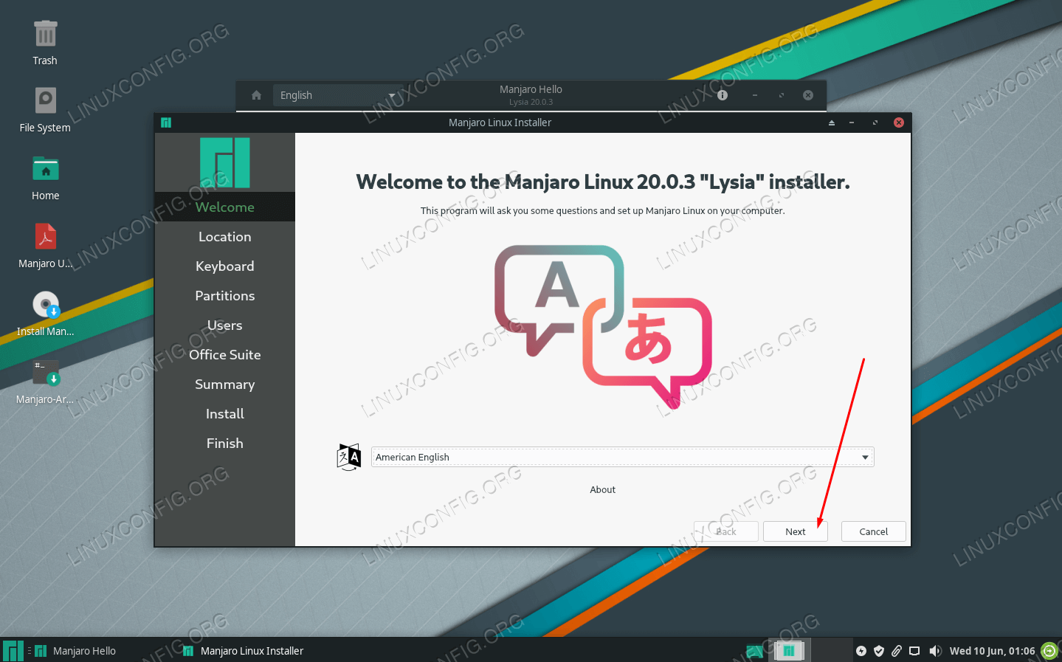](https://linuxconfig.org/images/07-manjaro-linux-windows-10-dual-boot.png)SELECT SYSTEM LANGUAGE

5.Select your timezone and click next.

[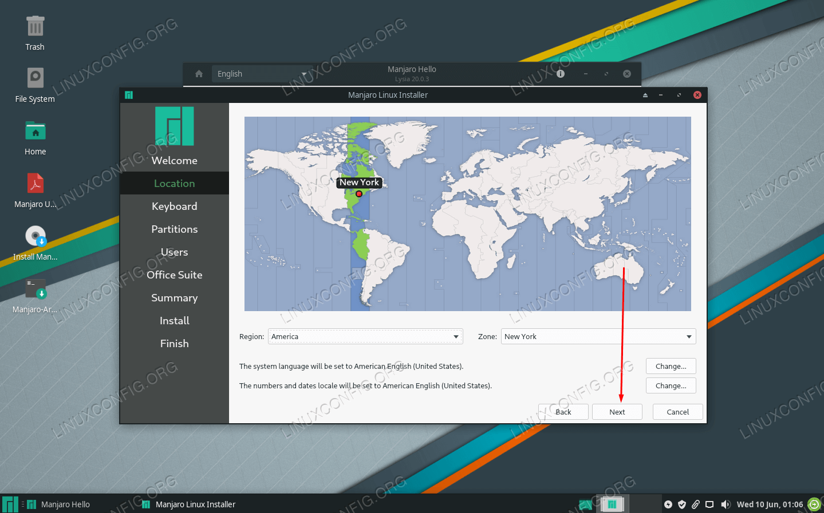](https://linuxconfig.org/images/08-manjaro-linux-windows-10-dual-boot.png)SELECT SYSTEM TIMEZONE

6.Select your keyboard layout and click next.

[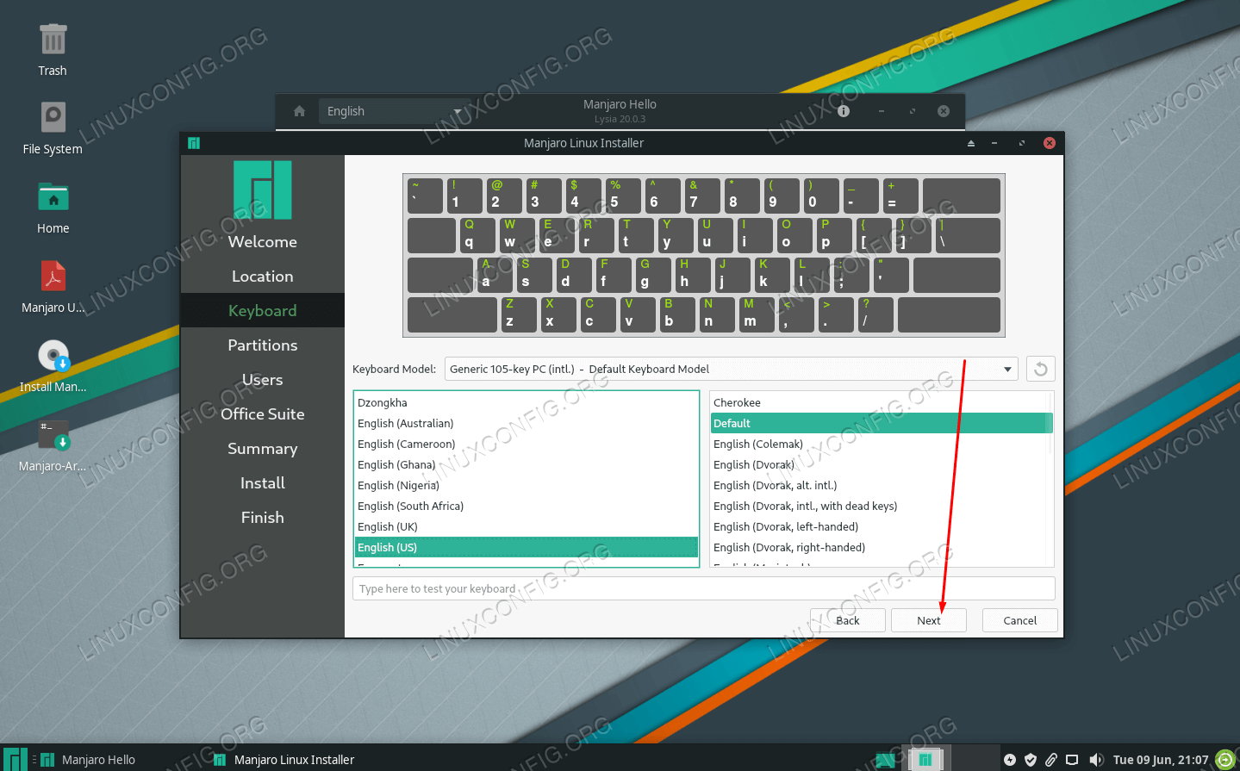](https://linuxconfig.org/images/09-manjaro-linux-windows-10-dual-boot.png)SELECT KEYBOARD LAYOUT

7.On the partitioning screen, select "Manual partitioning" and click next.

[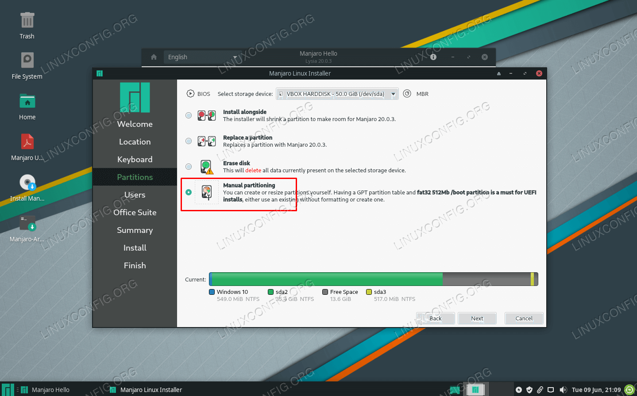](https://linuxconfig.org/images/10-manjaro-linux-windows-10-dual-boot.png)SELECT MANUAL PARTITIONING

8.Next, highlight the free space that we created earlier in Windows and click Create. Make sure that you have selected the right one, since you may see multiple sections labelled as "free space."

[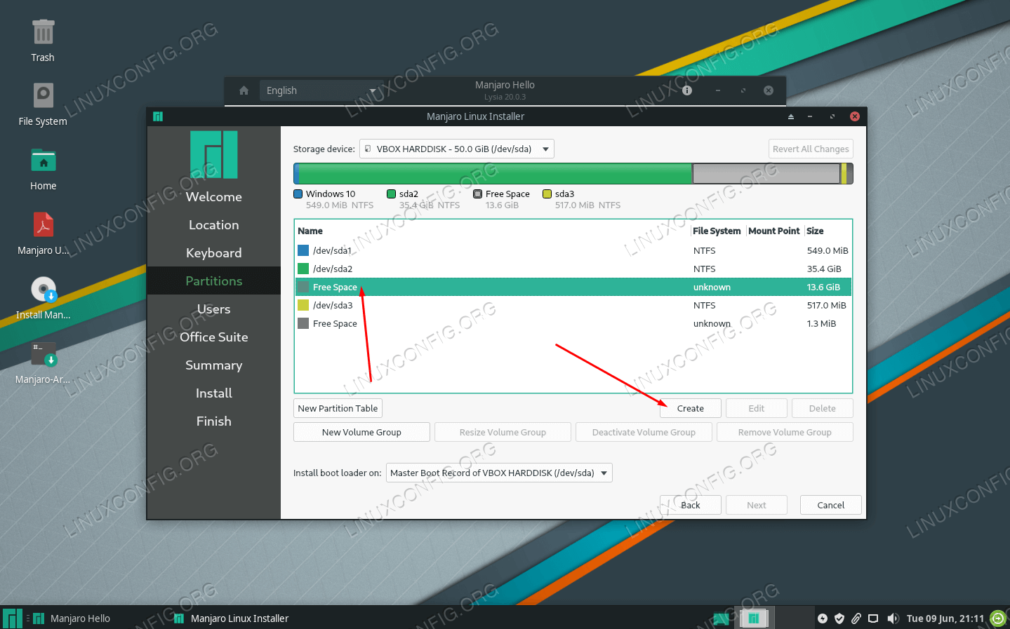](https://linuxconfig.org/images/11-manjaro-linux-windows-10-dual-boot.png)SELECT THE FREE SPACE FOR THE NEW MANJARO PARTITION

9.Manjaro recommends that our system have a swap partition equal to the size of our RAM, or 8 GB if the amount of RAM exceeds that. Reduce the size of this new partition by the amount of RAM you have in your system. If you have more than 8 GB of RAM, then only reduce this number by 8 GB (8,000 MB). This remaining space will be used as our swap partition that we'll configure in a moment. Click OK when you've made that change. Also make sure that you put / as the mount point.

[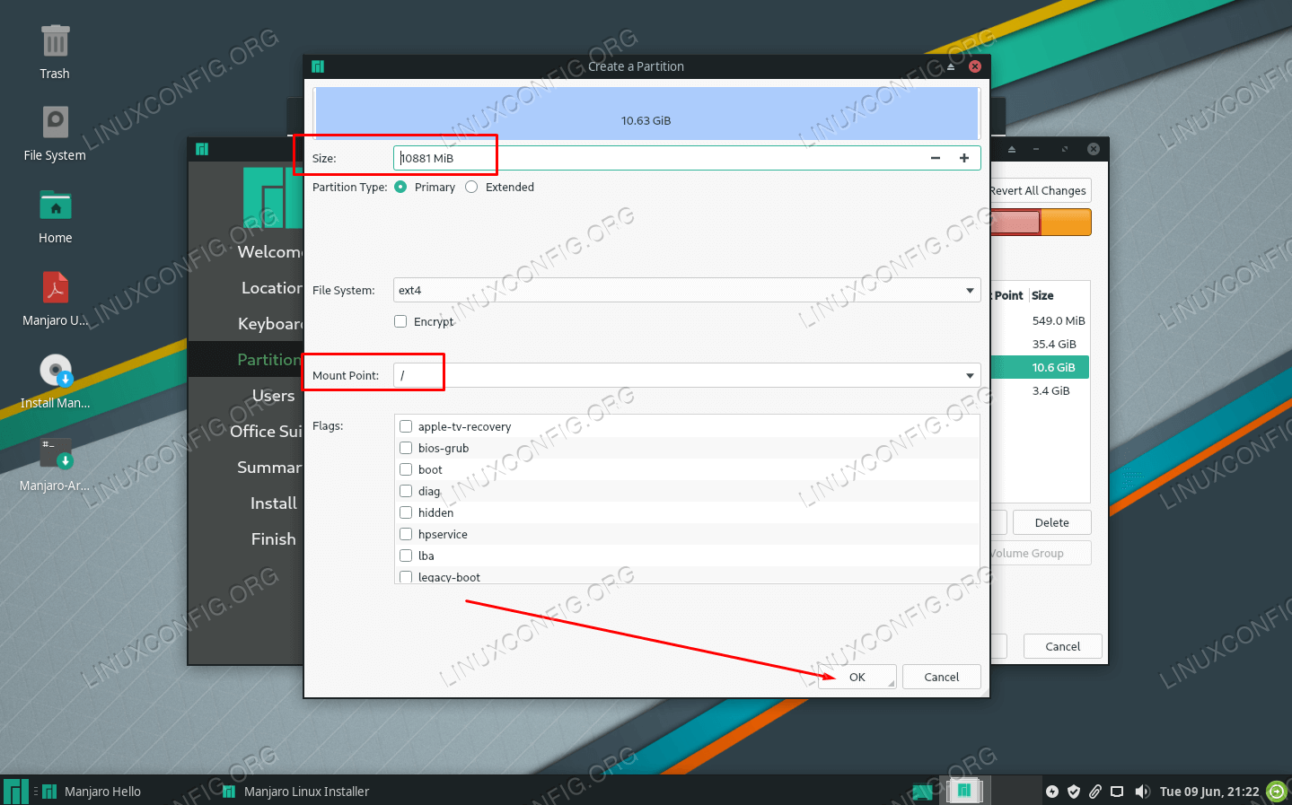](https://linuxconfig.org/images/12-manjaro-linux-windows-10-dual-boot.png)CONFIGURE PARTITION SIZE AND MOUNT POINT

10.You'll see your newly configured partition labelled as "New partition" in the Manjaro installer. Do you also see the the free space that you just configured? Highlight that and click Create. This will be our swap partition.

[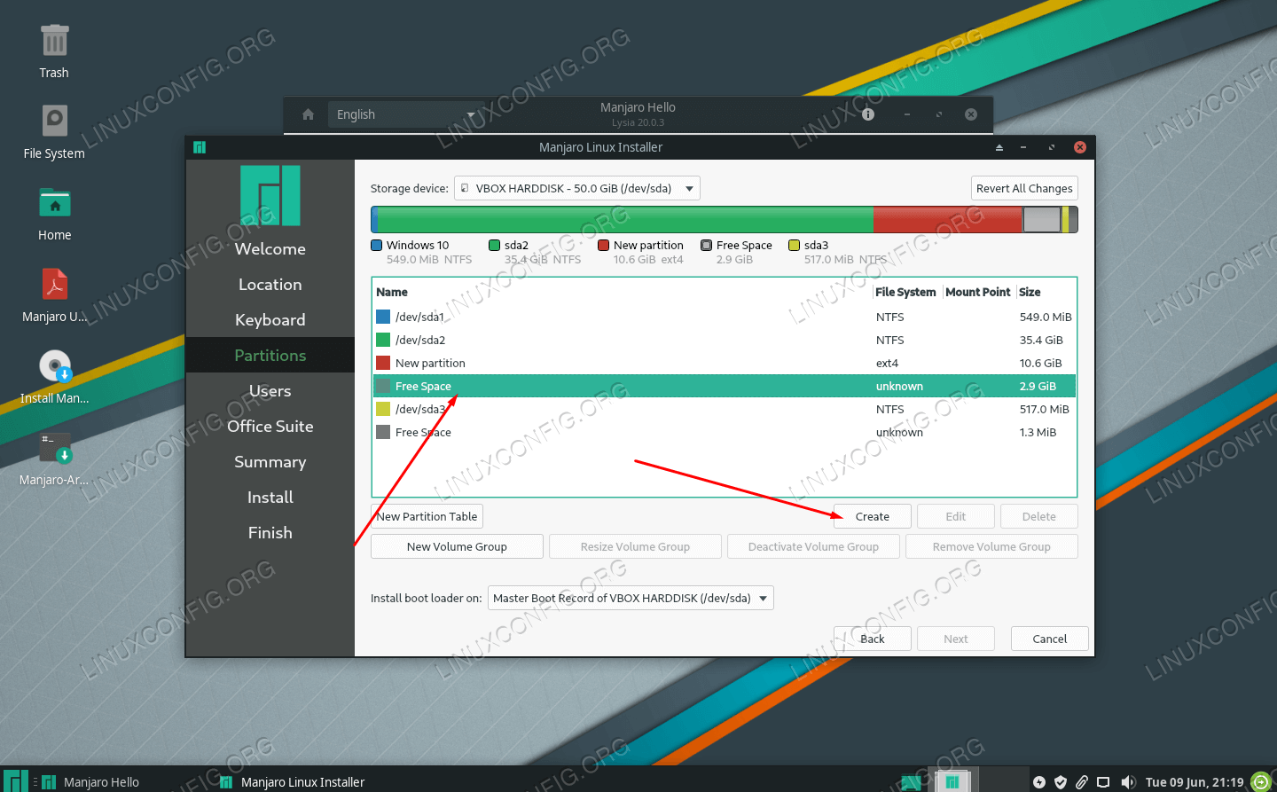](https://linuxconfig.org/images/13-manjaro-linux-windows-10-dual-boot.png)CONFIGURE THE OTHER FREE SPACE AS SWAP SPACE

11.Make the file system "linuxswap" and add the "swap" flag to this partition. Click OK and then click next on the Manjaro installer.

[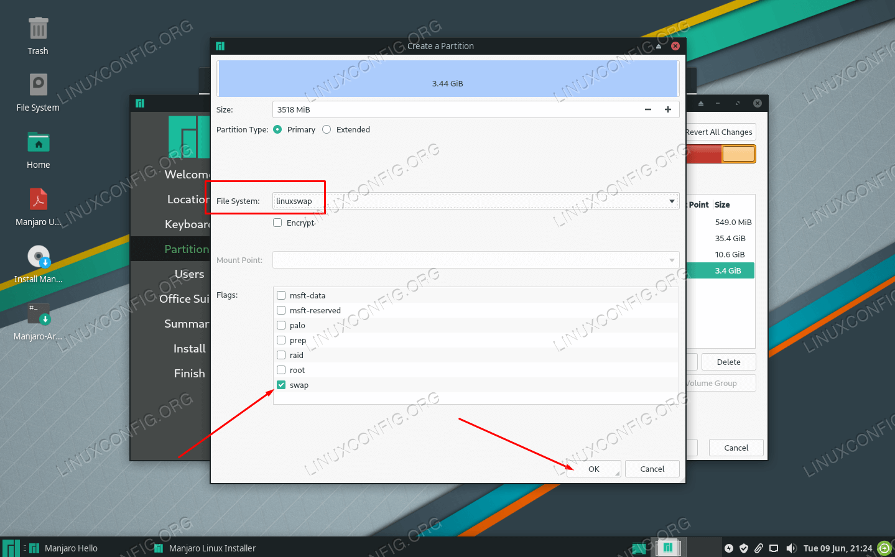](https://linuxconfig.org/images/14-manjaro-linux-windows-10-dual-boot.png)CONFIGURE FILE SYSTEM AND FLAGS

12.Fill out a new username, password, hostname, and root password for your system and click next.

[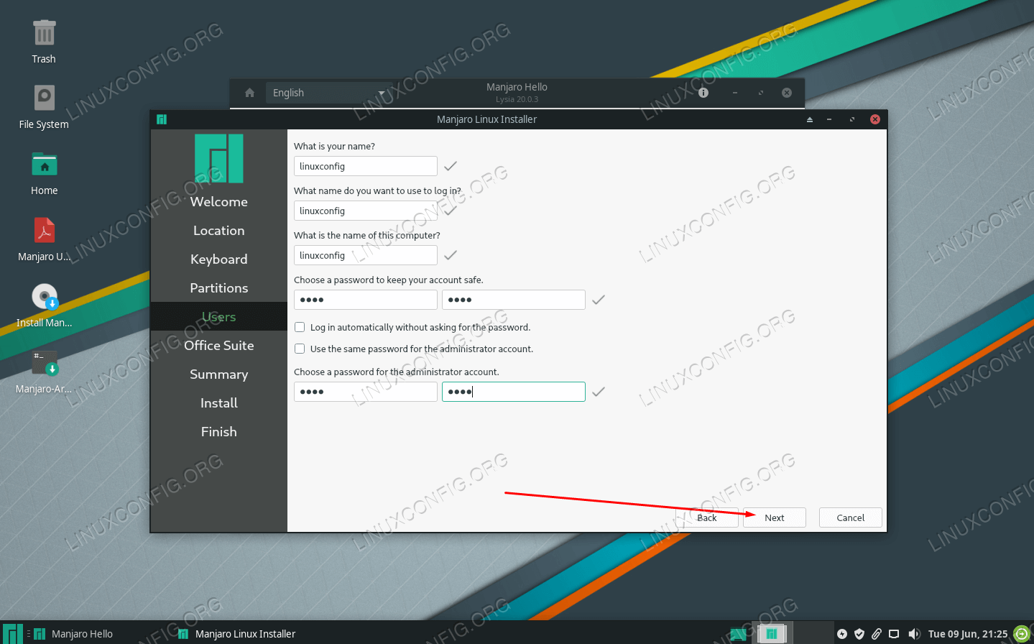](https://linuxconfig.org/images/15-manjaro-linux-windows-10-dual-boot.png)FILL OUT YOUR USER AND HOSTNAME INFORMATION

13.Manjaro will ask you which office suite you'd like to install on the system. Select your preferred package or click no office suite. Click next.

[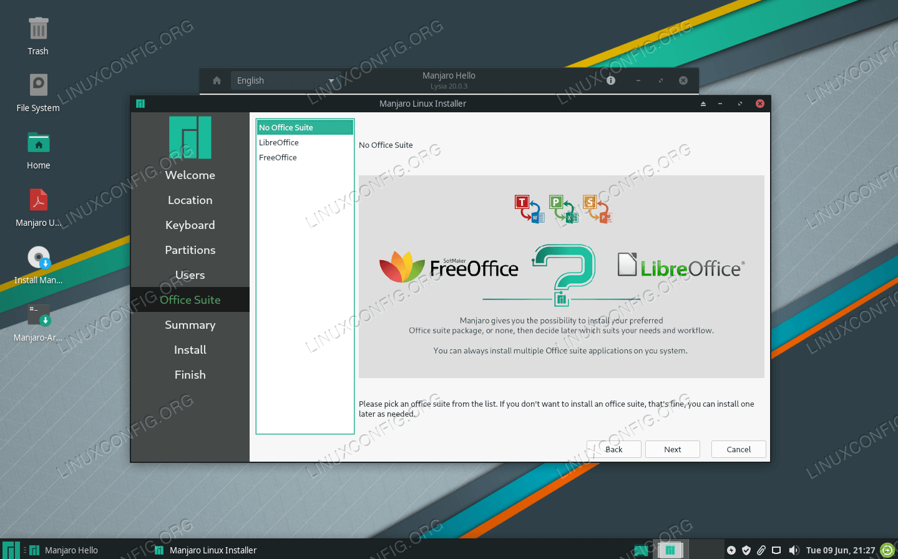](https://linuxconfig.org/images/16-manjaro-linux-windows-10-dual-boot.png)CHOOSE OFFICE SUITE

14.Manjaro will now ask you to review the upcoming partition changes. Make sure everything here looks correct. Once you click next, Manjaro will write the changes to your hard disk. Proceed when you are ready.

[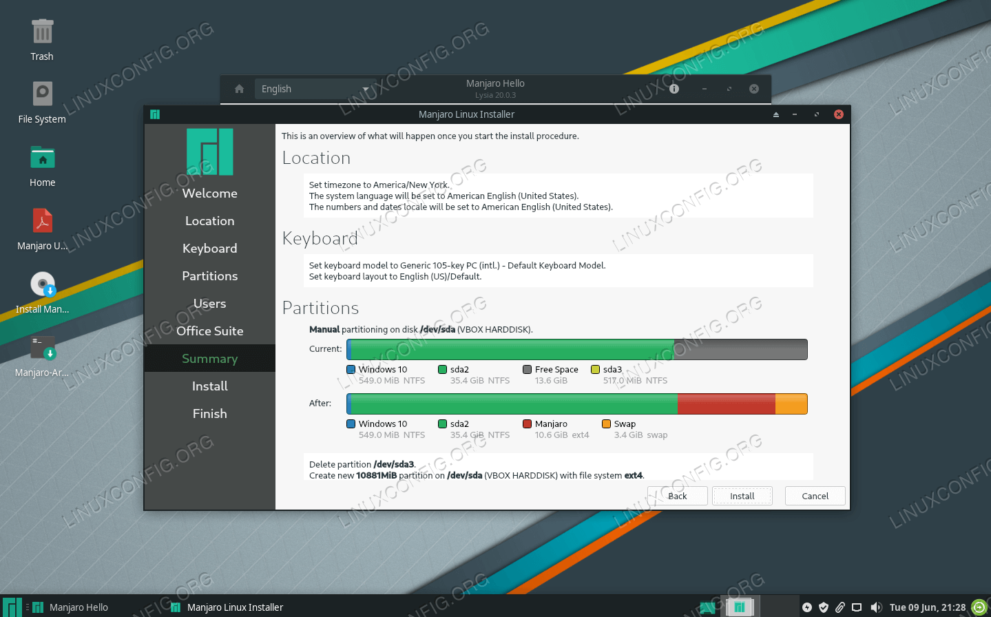](https://linuxconfig.org/images/17-manjaro-linux-windows-10-dual-boot.png)CAREFULLY REVIEW YOUR UPCOMING PARTITION CHANGES

15.Manjaro will now install. When it's finished, you'll be asked to reboot. Make sure you eject your installation media first.

**Loading into Manjaro or Windows 10**

From now on, when you start your system, Manjaro's bootloader will ask you which operating system you want to load into. Use your arrow keys to scroll up and down, and press enter to choose an option. After making your selection, the chosen operating system should load as normal.

[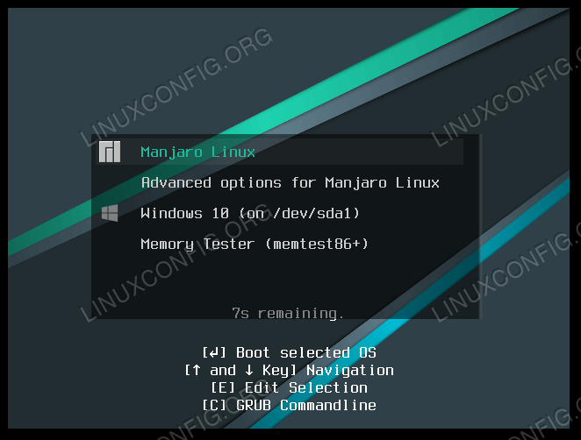](https://linuxconfig.org/images/18-manjaro-linux-windows-10-dual-boot.png)